Your name **Andrei BARYCHEUSKI** Date **20.09.2022**

**Good luck!**

**Introduction to the project:**

|  |  |
| --- | --- |
| Imagine that you are assigned to a new project as a tester.  Testing team: you and test team lead Mike.  This is a small mobile project for iOS.  “Canteen menu” application is developed for a huge company located all over the world. Application is targeted on company’s canteens stuff. It will be used for week menu management (creation, edition, etc).  Canteen employees are equipped with iPads or iPhones X.  After login to the application user (canteen employee) is redirected to “Menu List” screen with the list of menus for different company’s canteens (in different locations), “Country”, “City”, “Canteen” filters.  **New feature “Menu Editor” will be implemented during the upcoming iteration.**  Your task is:   1. Review the requirements for the new feature provided by BA Barbara 2. In case of any questions you have to write email to Barbara with request to clarify your questions 3. Provide estimations for test activities for this feature by email to your test lead Mike 4. Write test cases for the feature 5. Review provided screens with the implemented feature 6. Find and submit bugs in case of any 7. Send test results and your decision about quality of the feature to Mike (\*optional)   **Below you will find requirements for the feature and templates for emails, test cases, bug reports, etc. Please fill in only those templates that you think reasonable in scope of this feature. You can write any additional information if required.** | E:\lectures\Test 3\1.png |
| **Requirements for the new feature:**  AS an administrator  I CAN **create menu**:   1. I am in “Menu List” screen 2. I click “create” button - “Menu Editor” screen opens 3. I type canteen name in “Menu name” field 4. I choose canteen from list and click it 5. I select “To” date from date picker 6. I select “From” date from date picker 7. I click “save” button – “Menu List” screen opens, new menu is added to the list | E:\lectures\Test 3\2crop.png |
| AS an administrator  I CAN **edit menu**:   1. I am in “Menu List” screen 2. I click edit icon C:\Users\Lidziya_Smirnova\Desktop\Icons\89031-200.png - “Menu Editor” screen opens 3. From the dates panel I choose date I want to add dish offers to 4. In dish categories list I choose category I want to add dish offers to 5. If there are no dishes in the category – empty field is displayed 6. If the number of dishes exceeds the screen – the list can be scrolled 7. I can remove dish from the list 8. “Add dish” feature will be implemented later | |
| E:\lectures\Test 3\2.png | E:\lectures\Test 3\2a.png |

**Clarification letter to BA regarding new feature:**

|  |  |
| --- | --- |
| **To:** | Barbara Smith |
| **CC:** | Mike |
| **Subject:** | Questions to Requirements for Menu editor feature “Canteen menu” application |
| Hello, Barbara.  We are glad to implement the project on APP development for your company.  To fulfill the project successfully and on time I need to ask you several additional questions. They are:  1. Is point 3 in user scenario 1 correct (I type canteen name in “Menu name” field)?  2. For how many days a canteen stuff is planning the menu?  3. How many days from the specified time period should be shown in dates panel of Menu editor?  4. How many dish categories do you need and what are they?  5. What is the max charactors number in menu Name? Which letters, symbols, numbers can be used in Menu name?  6. Do you need a confirmation dialogue window for removing the dish from the list?  7. Can you give us a sample of dishes ordered by categories?  Looking forward to hearing from you.  Best regards,  Andrei Barycheuski  Tester  tel. +375445504495  e-mail: [seawavestar@mail.ru](https://e.mail.ru/compose?To=seawavestar@mail.ru) | |

**Test estimations for new feature to Test team lead:**

|  |  |
| --- | --- |
| **To:** | Mike |
| **CC:** |  |
| **Subject:** | Estimations for test activities for Menu editor feature “Canteen menu” application |
| Hello, Mike  I made the estimation for testing Menu editor feature “Canteen menu” application.  The time includes:  Analysis of documentation – 30 min  Creation of test environment (samples for dishes for dish categories and 15 test cases) – 1.5 hour;  Test cases execution and bug reporting (2 devices, 2 times, 15 test cases) – 3 hours;  Regression testing – 2 hours  Additional time (conversations, tee/coffee) – 1 hours  The total time – 8 hours or one working day.  Looking forward to hearing from you.  Best regards,  Andrei Barycheuski  tel. +375445504495  e-mail: [seawavestar@mail.ru](https://e.mail.ru/compose?To=seawavestar@mail.ru) | |

**Test cases for new feature:**

| **№** | **Req №** | **Module** | **Title** | **Test Description** | **Priority** | **Steps** | **Expected results** | **Passed/ Failed** | **Comments** |
| --- | --- | --- | --- | --- | --- | --- | --- | --- | --- |
| TC1 | User scenario1 | Menu editor | Creation of menu list with valid data in all fields | iPad or iPhone | Smoke | 1. Enter “Menu List” screen 2. Click “create” button  3. Type valid name in “Menu name” field  4. Choose canteen from list and click it  5. Select in “To” field valid date from date picker  6. Select in “From” field valid date from date picker  7. Click “save” button | 1.  2. “Menu Editor” screen opens  3.  4.  5.  6.  7. “Menu List” screen opens, new menu is added to the list | Failed |  |
| TC2 | User scenario1 | Menu editor | Creation of menu list with empty name field | iPad or iPhone | Smoke | 1. Enter “Menu List” screen 2. Click “create” button  3. Choose canteen from list and click it  4. Select in “To” field valid date from date picker  5. Select in “From” field valid date from date picker  6. Click “save” button | 1.  2. “Menu Editor” screen opens  3.  4.  5.  6. Save option is unavailable/ form shows mistake | Blocked |  |
| TC3 | User scenario1 | Menu editor | Creation of menu list with invalid Menu name | iPad or iPhone | Critical | 1. Enter “Menu List” screen 2. Click “create” button  3. Type invalid name in “Menu name” field  4. Choose canteen from list and click it  5. Select in “To” field valid date from date picker  6. Select in “From” field valid date from date picker  7. Click “save” button | 1.  2. “Menu Editor” screen opens  3.  4.  5.  6.  7. Save option is unavailable/ form shows mistake | Blocked |  |
| TC4 | User scenario1 | Menu editor | Creation of menu list with invalid Menu name (5 spaces) | iPad or iPhone | Critical | 1. Enter “Menu List” screen 2. Click “create” button  3. Type 5 spaces in “Menu name” field  4. Choose canteen from list and click it  5. Select in “To” field valid date from date picker  6. Select in “From” field valid date from date picker  7. Click “save” button | 1.  2. “Menu Editor” screen opens  3.  4.  5.  6.  7. Save option is unavailable/ form shows mistake | Blocked |  |
| TC5 | User scenario1 | Menu editor | Creation of menu list with not selected canteen name | iPad or iPhone | Critical | 1. Enter “Menu List” screen 2. Click “create” button  3. Type valid name in “Menu name” field  4. Select in “To” field valid date from date picker  5. Select in “From” field valid date from date picker  6. Click “save” button | 1.  2. “Menu Editor” screen opens  3.  4.  5.  6. Save option is unavailable/ form shows mistake | Blocked |  |
| TC6 | User scenario1 | Menu editor | Creation of menu list without period | iPad or iPhone | Critical | 1. Enter “Menu List” screen 2. Click “create” button  3. Type valid name in “Menu name” field  4. Choose canteen from list and click it  5. Select in “To” field current date from date picker  6. Select in “From” field current date from date picker  7. Click “save” button | 1.  2. “Menu Editor” screen opens  3.  4.  5.  6.  7. Save option is unavailable/ form shows mistake | Blocked |  |
| TC7 | User scenario1 | Menu editor | Creation of menu list with past period | iPad or iPhone | Critical | 1. Enter “Menu List” screen 2. Click “create” button  3. Type valid name in “Menu name” field  4. Choose canteen from list and click it  5. Select in “To” field (current date -1 days) value from date picker  6. Select in “From” field (current date -10 day) value from date picker  7. Click “save” button | 1.  2. “Menu Editor” screen opens  3.  4.  5.  6.  7. Save option is unavailable/ form shows mistake | Blocked |  |
| TC8 | User scenario1 | Menu editor | Creation of menu list with incorrect period | iPad or iPhone | Critical | 1. Enter “Menu List” screen 2. Click “create” button  3. Type valid name in “Menu name” field  4. Choose canteen from list and click it  5. Select in “To” field current date value from date picker  6. Select in “From” field (current date +5 day) value from date picker  7. Click “save” button | 1.  2. “Menu Editor” screen opens  3.  4.  5.  6.  7. Save option is unavailable/ form shows mistake | Blocked |  |
| TC9 | User scenario2 | Menu editor | Day buttons and dish categories selection | iPad or iPhone | Smoke | Pre-condition: Make a stab(driver) with samples data for dishes in categories  1. Enter “Menu List” screen 2. Click “edit” icon  3. Click days icon  4. Click within each selected day on all dish categories | All buttons and options are available.  If there are no dishes in the category – empty field is displayed  If the number of dishes exceeds the screen – the list can be scrolled | Blocked |  |
| TC10 | User scenario2 | Menu editor | Delete of the dish | iPad or iPhone | Smoke | Pre-condition: Make a stab(driver) with samples data for dishes in categories  1. Enter “Menu List” screen 2. Click “edit” icon  3. Select day icon  4. Select dish categories with name of the dishes  5. Press delete icon | Dish name is deleted or dialogue button appears to confirm delete of the dish name (TBD) | Blocked |  |
| TC11 | App | Menu editor | APP orientation | iPad or iPhone | Critical | Pre-condition: Select autorotation mode in device  1. Enter “Menu List” screen 2. Rotate device | App window should rotate with device rotation | Blocked |  |
| TC12 | User scenario1 | Menu editor | APP interruption | iPad or iPhone | Critical | 1. Enter “Menu List” screen 2. Click “create” button  3. Type valid name in “Menu name” field  4. Decline/accept incoming call | 1.  2.  3.  4. Input data are saved | Blocked |  |
| TC13 | User scenario1 | Menu editor | Change of device mode to flight regime | iPad or iPhone | Critical | 1. Enter “Menu List” screen 2. Click “create” button  3. Type valid name in “Menu name” field  4. Choose canteen from list and click it  5. Change device mode to flight regime  6. Select in “To” field valid date from date picker  7. Select in “From” field valid date from date picker  8. Click “save” button | 1.  2.  3.  4.  5.  6.  7.  8. Input data are saved | Blocked |  |
| TC14 | User scenario1 | Menu editor | APP pending regime | iPad or iPhone | Critical | 1. Enter “Menu List” screen 2. Click “create” button  3. Type valid name in “Menu name” field  4. Send APP in pending regime  5. Enter APP from pending regime | 1.  2.  3.  4.  5. Input data are saved | Blocked |  |

**“Menu Editor” feature is ready for testing:**

Developers have finished implementation of “Menu Editor” feature. Build with the feature is released and successfully installed.

When editing the menu you see the following screen:

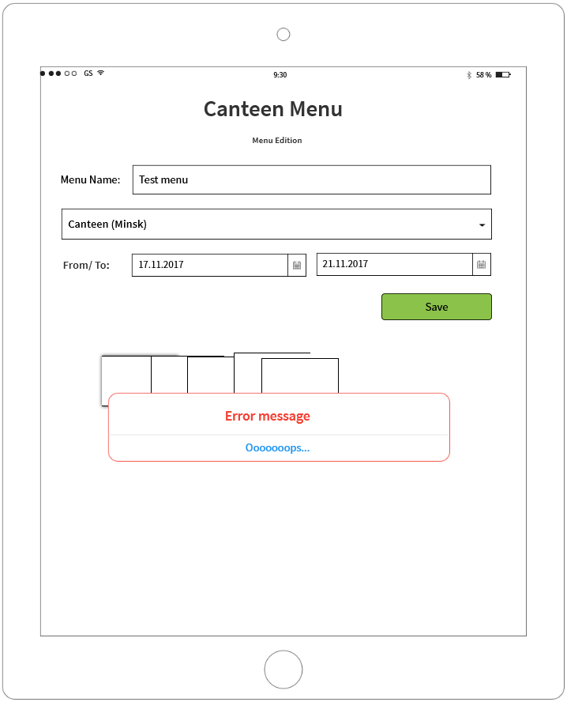

**If you see any bugs in this screen, you can post them below:**

**Bug reports:**

|  |  |
| --- | --- |
| **Bug ID** | **#1** |
| **Summary** | New Menu can not be added to Menu list |
| **Description** | iPad or iPhone |
| **Severity** | Critical |
| **Steps to reproduce** | 1. Enter “Menu List” screen 2. Click “create” button  3. Type valid name in “Menu name” field  4. Choose canteen from list and click it  5. Select in “To” field valid date from date picker  6. Select in “From” field valid date from date picker  7. Click “save” button  **Exp. Result:** “Menu List” screen opens, new menu is added to the list  **Akt.result:** Press on Save button shows mistake message |
| **Bug ID** | **#2** |
| **Summary** | Incorrect name of module |
| **Description** | iPad or iPhone |
| **Severity** | Medium |
| **Steps to reproduce** | 1. Enter “Menu List” screen 2. Click “create” button  3. Look at the second row from above on the screen  Exp. Result: Module name in the second row of the screen is “Menu Edition”  Akt.result: Module name is to be “Menu Editor”  E:\lectures\Test 3\4.png |
| **Bug ID** | **#3** |
| **Summary** | Search button for canteen name is unavailable |
| **Description** | iPad or iPhone |
| **Severity** | Medium |
| **Steps to reproduce** | 1. Enter “Menu List” screen 2. Click “create” button  3. Look at canteen Name Line  Exp. Result: Button for search of canteen Name is available in canteen Name Line  Akt.result: There is no button for search of canteen Name in canteen Name Line  E:\lectures\Test 3\4.png |

**Test result report to Test team lead:**

|  |  |
| --- | --- |
| **To:** | Mike |
| **CC:** |  |
| **Subject:** | Test results for Menu editor feature “Canteen menu” application |
| Hello, Mike  For the reporting period **tasks done**:   1. Send an e-mail to customer with 8 additional questions on requirements 2. Testing time estimation 3. Test-cases writing (14 test cases) 4. Test-cases testing (14 test cases):   Passed – 0;  Failed – 1;  Blocked – 13.   1. Bugs reporting (3 bug)   **Test Status: Red**  **Test Analysis:** New feature “Menu editor” did not path smoke testing. Fail in smoke testing did not allow me to go further with test cases execution More over I found two more bugs. I do think we have to report this to management.  **Plans for next week:** receive build ver.2, start smoke testing execution of bild ver.2.  **Risks:** Due to the critical bug we have risk for PROD deployment delay.  Looking forward to hearing from you.  Best regards,  Andrei Barycheuski  tel. +375445504495  e-mail: [seawavestar@mail.ru](https://e.mail.ru/compose?To=seawavestar@mail.ru) | |

**Thank you!**